Google Cloud

**Introduction:**

In the age of digital transformation, data has emerged as the lifeblood of modern enterprises, driving innovation, informing decision-making, and fuelling growth. The exponential growth in data volumes, coupled with advancements in machine learning and artificial intelligence (AI), has revolutionized how organizations store, process, and derive insights from data. At the heart of this revolution lies the convergence of Big Data storage and machine learning technologies, enabling organizations to extract actionable insights and unlock new opportunities.

**The Significance of Big Data Storage:**

The term "Big Data" refers to the vast volumes of structured, semi-structured, and unstructured data generated from various sources, including social media platforms, IoT devices, sensors, and transactional systems. Effectively storing, managing, and analysing this avalanche of data is essential for organizations looking to gain a competitive edge in today's data-driven economy. Traditional storage solutions often struggle to cope with the scale, variety, and velocity of Big Data, necessitating the adoption of advanced storage architectures and technologies.

**Harnessing the Power of Machine Learning:**

Machine learning, a subset of AI, empowers organizations to extract valuable insights from Big Data by automatically identifying patterns, trends, and correlations within the data. By leveraging machine learning

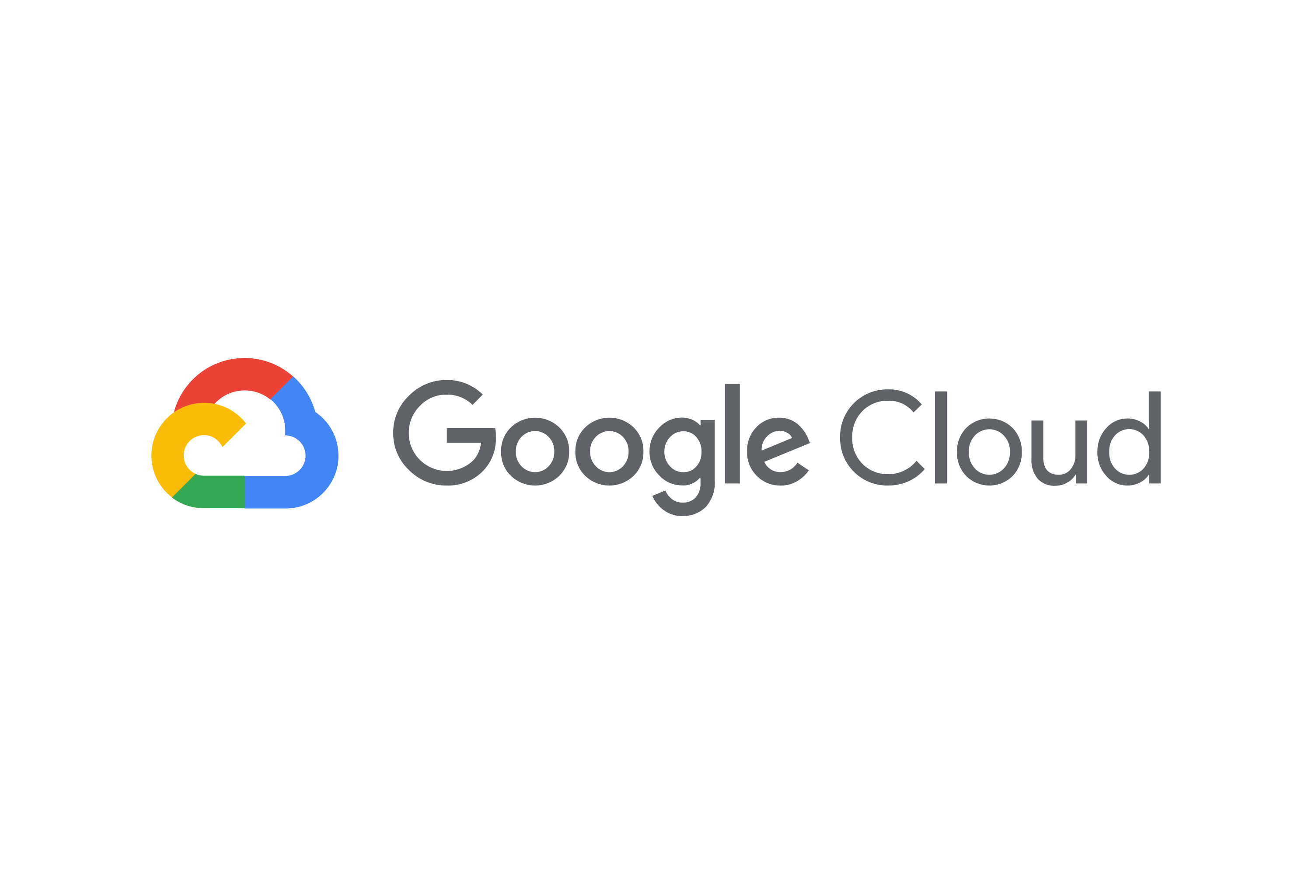algorithms, organizations can uncover hidden insights, predict future outcomes, and optimize decision-making processes. From predictive analytics to natural language processing, machine learning algorithms have applications across diverse industries, including finance, healthcare, retail, and manufacturing.

**The Role of Cloud Platforms:**

Cloud computing has revolutionized the way organizations store, process, and analyze data, offering scalability, flexibility, and cost-effectiveness. Leading cloud providers, including Google Cloud, Amazon Web Services (AWS), and Microsoft Azure, offer a range of services tailored to meet the demands of storing Big Data and implementing machine learning solutions. These cloud platforms provide a comprehensive suite of storage services, data analytics tools, and machine learning frameworks, enabling organizations to harness the full potential of their data assets.

**Comparative Analysis of Cloud Platforms:**

While Google Cloud, AWS, and Azure dominate the cloud computing landscape, each platform offers unique features, capabilities, and pricing models. A comparative analysis of these cloud platforms is essential for organizations seeking to make informed decisions regarding their data storage and machine learning initiatives. Factors such as performance, scalability, reliability, security, and cost-effectiveness must be carefully evaluated to determine the optimal cloud platform for specific use cases and business requirements.

In this report, we delve into the intricacies of storing Big Data, implementing machine learning solutions, and conducting a comparative analysis of Google Cloud, AWS, and Azure. By exploring the strengths and weaknesses of each cloud platform, organizations can make informed decisions and capitalize on the transformative potential of Big Data and machine learning technologies.

**Abstract**

In today's digital age, the exponential growth of data has necessitated advanced storage solutions and machine learning techniques to derive actionable insights and drive innovation. This report explores the intersection of storing Big Data, implementing machine learning solutions, and comparing leading cloud platforms, namely Google Cloud, Amazon Web Services (AWS), and Microsoft Azure.

The report begins with an overview of the challenges and considerations associated with storing Big Data, including discussions on distributed storage systems, data compression, and data lifecycle management. It then delves into the fundamentals of machine learning, highlighting common algorithms and real-world applications across various industries.

A comparative analysis of Google Cloud, AWS, and Azure is provided, focusing on their respective storage services, machine learning capabilities, and pricing models. Case studies and use cases illustrate the practical applications and benefits of cloud-based Big Data storage and machine learning initiatives.

In conclusion, the report summarizes key findings and offers insights, recommendations, and best practices for organizations considering cloud-based solutions for their Big Data and machine learning needs.

Google Cloud

for storing big data

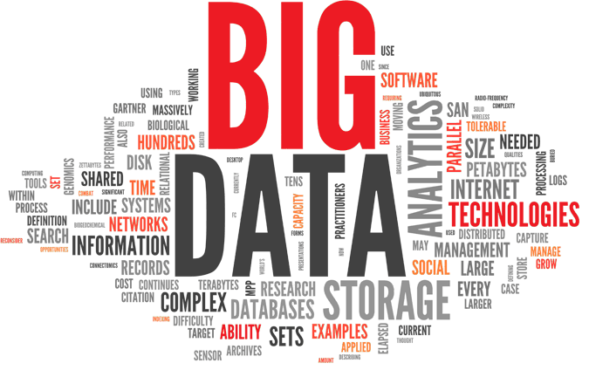

**Taming the Big Data Beast: An Overview of Storage on Google Cloud**

The ever-growing deluge of data, aptly named Big Data, presents a challenge for businesses. Traditional storage solutions buckle under the immense volume, variety, and velocity of Big Data. Here's where Google Cloud Platform (GCP) steps in, offering a comprehensive and scalable solution for storing and managing your Big Data.

* **Storage Powerhouse: Google Cloud Storage**

At the core of GCP's Big Data storage lies Cloud Storage. This object storage solution boasts exceptional scalability and cost-effectiveness. Think of it as a massive, secure virtual warehouse for your raw Big Data, accommodating any amount of information you throw at it. Cloud Storage integrates seamlessly with other GCP services, making data readily available for processing and analysis.

* **BigQuery: The SQL Hero for Big Data**

BigQuery is a game-changer for Big Data analytics. This serverless data warehouse allows you to store and analyze massive datasets using familiar SQL syntax. Imagine querying petabytes of data with blazing-fast speed! BigQuery makes large-scale data exploration and business intelligence tasks a breeze, helping you uncover hidden patterns and make data-driven decisions.

* **Dataflow: Stream Processing Made Easy**

Real-time data analysis is crucial for many businesses. Dataflow simplifies the creation and execution of data pipelines for both batch and streaming data. This fully managed service ensures efficient and scalable data processing, empowering you to gain real-time insights from your Big Data streams. No more waiting for batch processing – get insights as the data arrives!

* **Datapost: Leverage the Power of Open Source**

Need the power of Apache Hadoop and Spark for complex data processing tasks? Datapost provides a managed service for running large-scale Big Data workloads on these popular open-source frameworks. Spin up and manage Hadoop and Spark clusters on-demand, allowing you to tackle demanding data processing tasks with ease.

By leveraging this suite of services, Google Cloud empowers you to effectively store, manage, and analyse your Big Data. Gone are the days of struggling with limited storage capacity and cumbersome data processing. Google Cloud offers a scalable, secure, and cost-effective solution to unlock the true potential of your Big Data and propel your business forward.

**Benefits of using Google Cloud for Big Data**

The vast potential of Big Data can be hindered by traditional data storage solutions. Luckily, Google Cloud Platform (GCP) offers a powerful suite of services specifically designed to tackle the challenges of Big Data storage and management. Here's a closer look at the key benefits reaped by organizations that leverage Google Cloud for their Big Data needs:

* **Unmatched Scalability:** Big Data, by its very nature, is constantly growing. Traditional storage solutions often struggle to keep pace with this ever-increasing volume. GCP excels in this area. Its infrastructure is built for limitless scalability, allowing you to effortlessly scale your storage capacity up or down based on your evolving data requirements. No matter how much data you accumulate, Google Cloud can handle it.
* **Cost-Effectiveness:** Traditional data storage often involves significant upfront costs for hardware and infrastructure. GCP's pay-as-you-go pricing model eliminates this burden. You only pay for the resources you use, making it a highly cost-effective solution for Big Data storage. This allows you to optimize your budget and focus on extracting valuable insights from your data.
* **Enhanced Security and Compliance:** Big Data often contains sensitive information. Security breaches can have devastating consequences. Google Cloud prioritizes data security. Their world-class infrastructure and comprehensive access controls ensure the safety and privacy of your data. Additionally, GCP adheres to rigorous industry compliance standards, providing peace of mind for businesses operating in regulated sectors.
* **Simplified Management:** Managing a Big Data infrastructure in-house can be a complex and time-consuming task. Google Cloud's managed services, such as Big Query and Dataflow, take the burden off your IT team. These services eliminate the need for complex infrastructure management and ongoing maintenance, allowing your IT professionals to focus on core business objectives and strategic data initiatives.
* **Streamlined Analytics:** Storing Big Data is just the first step. To unlock its true potential, you need powerful tools for analysis. GCP offers a seamless integration between its various Big Data services. Data can be easily ingested, stored, processed, and analyzed within the Google Cloud ecosystem. This streamlined approach empowers you to uncover hidden patterns and gain valuable insights from your data faster and more efficiently.

**Machine Learning on Google Cloud:**

Machine learning (ML) is revolutionizing numerous industries, but its adoption can be hindered by resource limitations and complex infrastructure. Google Cloud Platform (GCP) offers a robust and versatile suite of tools and services that can empower businesses to leverage ML effectively. Here's a breakdown of the key benefits GCP brings to the table for machine learning endeavours:

* **Simplified Development and Deployment:** GCP provides a collection of pre-built AI Services (Vertex AI being a central hub) that streamline the development and deployment of ML models. These services handle repetitive tasks like data preparation, model training, and hyperparameter tuning, allowing data scientists to focus on core ML tasks and accelerate the time-to-insight.
* **Scalability and Flexibility:** ML projects can require significant computing power, especially during the training phase. GCP's scalable infrastructure allows you to easily adjust resources based on your project's needs. You can leverage powerful GPUs and TPUs to train complex models efficiently, and then scale down to cost-effective options for deployment.
* **Cost-Effectiveness:** GCP's pay-as-you-go pricing model ensures you only pay for the resources you use. This is particularly beneficial for ML projects with fluctuating resource requirements. You can experiment with different models and datasets without incurring excessive upfront costs.
* **Collaboration and Experimentation:** GCP fosters a collaborative environment for data science teams. Cloud-based tools and services enable seamless sharing of data, models, and code, encouraging collaboration and faster iteration cycles. Additionally, GCP offers pre-trained models and AutoML capabilities that make experimentation easier and more accessible for data scientists of all experience levels.
* **High Performance and Efficiency:** GCP's infrastructure is built for speed and efficiency. Cutting-edge hardware like Tensor Processing Units (TPUs) and custom Machine Learning accelerators can significantly reduce training times for complex models. This allows you to iterate faster and bring your ML solutions to market quicker.
* **Security and Reliability:** GCP prioritizes data security and infrastructure reliability. Your sensitive data and ML models are protected by robust access controls and encryption measures. Additionally, GCP's global infrastructure ensures high availability and minimizes the risk of downtime for your ML applications.

**Benefits of Using Google Cloud for Machine Learning**

Machine learning (ML) is revolutionizing numerous industries, but its adoption can be hindered by resource limitations and complex infrastructure. Google Cloud Platform (GCP) offers a robust and versatile suite of tools and services that can empower businesses to leverage ML effectively. Here's a breakdown of the key benefits GCP brings to the table for machine learning endeavours:

* **Simplified Development and Deployment:** GCP provides a collection of pre-built AI Services (Vertex AI being a central hub) that streamline the development and deployment of ML models. These services handle repetitive tasks like data preparation, model training, and hyperparameter tuning, allowing data scientists to focus on core ML tasks and accelerate the time-to-insight.
* **Scalability and Flexibility:** ML projects can require significant computing power, especially during the training phase. GCP's scalable infrastructure allows you to easily adjust resources based on your project's needs. You can leverage powerful GPUs and TPUs to train complex models efficiently, and then scale down to cost-effective options for deployment.
* **Cost-Effectiveness:** GCP's pay-as-you-go pricing model ensures you only pay for the resources you use. This is particularly beneficial for ML projects with fluctuating resource requirements. You can experiment with different models and datasets without incurring excessive upfront costs.
* **Collaboration and Experimentation:** GCP fosters a collaborative environment for data science teams. Cloud-based tools and services enable seamless sharing of data, models, and code, encouraging collaboration and faster iteration cycles. Additionally, GCP offers pre-trained models and AutoML capabilities that make experimentation easier and more accessible for data scientists of all experience levels.
* **High Performance and Efficiency:** GCP's infrastructure is built for speed and efficiency. Cutting-edge hardware like Tensor Processing Units (TPUs) and custom Machine Learning accelerators can significantly reduce training times for complex models. This allows you to iterate faster and bring your ML solutions to market quicker.
* **Security and Reliability:** GCP prioritizes data security and infrastructure reliability. Your sensitive data and ML models are protected by robust access controls and encryption measures. Additionally, GCP's global infrastructure ensures high availability and minimizes the risk of downtime for your ML applications.

**Case Study:**

**Big Data and Machine Learning Success Stories on Google Cloud**

Google Cloud empowers businesses of all sizes to harness the power of Big Data and Machine Learning (ML). Here are a few compelling case studies that showcase the transformative impact of GCP:

**Big Data Analytics:**

* **Ivy Tech Community College:** Struggling to manage 12 million student data points, Ivy Tech shifted to GCP's BigQuery. This enabled them to scale their data storage, analyze student engagement effectively, and develop an ML algorithm to predict course outcomes with an impressive 80% accuracy [source: Google for Education - Ivy Tech case study].
* **Spotify:** With a massive user base and constant data generation, Spotify utilizes Big Query for data warehousing. This allows them to analyse user behaviour, music preferences, and other data points at scale. These insights empower them to personalize recommendations, improve the user experience, and drive subscriber growth.

**Machine Learning Applications:**

* **Ocado:** A leading online grocery retailer, Ocado leverages Google Cloud's Vertex AI and AI Platform to develop and deploy ML models for demand forecasting. This ML-powered system helps them optimize inventory management, reduce waste, and ensure efficient deliveries.
* **Colgate-Palmolive:** This global consumer goods giant utilizes Google Cloud's ML capabilities to analyse customer data and predict consumer trends. These insights allow them to personalize marketing campaigns, optimize product development, and stay ahead of the competition.
* **National Cancer Institute (NCI):** NCI leverages Google Cloud's secure and scalable infrastructure to support the "Institute for Systems Biology-Cancer Gateway in the Cloud." This initiative facilitates data sharing and collaboration among researchers, accelerating advancements in cancer research.

**Big Data and Machine Learning Success Stories on Google Cloud**

These are just a few examples of how Google Cloud is empowering businesses to leverage Big Data and Machine Learning. Here are some additional success stories that showcase the versatility of GCP:

* **Healthcare:** Hospitals and healthcare providers are increasingly using Big Data and ML to improve patient care. For instance, Cleveland Clinic leverages GCP to analyse vast amounts of medical data to identify patients at risk of sepsis. Early detection of sepsis can significantly improve patient outcomes.
* **Manufacturing:** Manufacturing companies are utilizing Big Data and ML to optimize production processes, streamline supply chains, and predict equipment failures. Honeywell, for example, utilizes Google Cloud to analyse sensor data from their manufacturing plants. This allows them to identify potential issues before they occur, preventing costly downtime.
* **Retail:** Retailers are embracing Big Data and ML to personalize the shopping experience, target advertising more effectively, and optimize inventory management. The Home Depot, a leading home improvement retailer, uses GCP to analyse customer data and personalize product recommendations. This results in increased customer satisfaction and sales growth.
* **Media and Entertainment:** Media and entertainment companies are using Big Data and ML to personalize content recommendations, optimize content delivery, and detect copyright infringement. Netflix, for example, leverages Google Cloud's Big Query for data warehousing and analytics. This enables them to analyse viewer behaviour and recommend content that users are more likely to enjoy.

**Comparison of Google Cloud with other cloud providers**

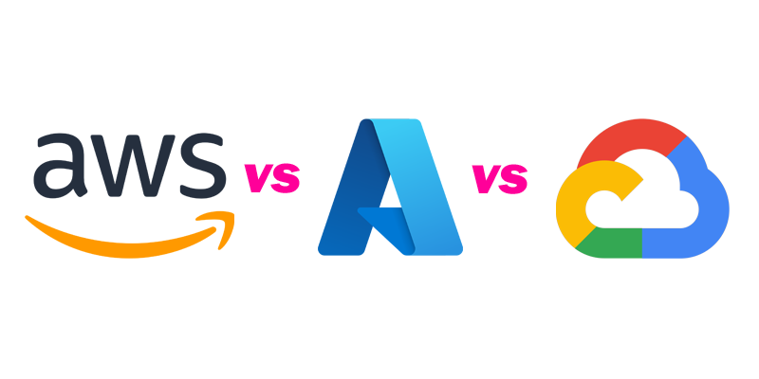

|  |  |  |  |
| --- | --- | --- | --- |
| Feature | Google Cloud Platform (GCP) | Amazon Web Services (AWS) | Microsoft Azure |
| Storage Services | Cloud Storage (object), Bigtable (NoSQL), Cloud SQL (relational) | S3 (object), EBS (block), DynamoDB (NoSQL), Redshift (data warehouse) | Blob storage (object), Azure Files (managed file shares), Cosmos DB (NoSQL), Azure SQL Database (relational) |
| Big Data Analytics | Big Query (serverless data warehouse), Dataflow (stream & batch processing), Datapost (Hadoop & Spark) | Redshift (data warehouse), EMR (Hadoop & Spark), Kinesis (stream processing) | Azure Synapse Analytics (data warehouse), Databricks (Hadoop & Spark), Stream Analytics (stream processing) |
| Scalability | Highly scalable, pay-as-you-go pricing | Highly scalable, pay-as-you-go pricing | Highly scalable, pay-as-you-go pricing |
| Cost-Effectiveness | Competitive with pay-as-you-go model, potential discounts for sustained use | Wide range of options, some with lower upfront costs, complex pricing structure | Competitive pricing, integration with Microsoft products can be cost-effective |
| Security | Robust access controls, encryption, focus on data privacy | Comprehensive security features, compliance certifications | Multi-layered security, integrates with Azure Active Directory |

**Comparison of Google Cloud with other cloud providers for Big Data**

|  |  |  |  |
| --- | --- | --- | --- |
| Feature | Google Cloud Platform (GCP) | Amazon Web Services (AWS) | Microsoft Azure |
| Storage Services | Cloud Storage (object storage), Bigtable (NoSQL), Cloud SQL (relational) | S3 (object storage), EBS (block storage), DynamoDB (NoSQL), Redshift (data warehouse) | Blob storage (object storage), Azure Files (managed file shares), Cosmos DB (NoSQL), Azure SQL Database (relational) |
| Big Data Analytics | Big Query (serverless data warehouse), Dataflow (stream & batch processing), Datapost (Hadoop & Spark) | Redshift (data warehouse), EMR (Hadoop & Spark), Kinesis (stream processing) | Azure Synapse Analytics (data warehouse), Databricks (Hadoop & Spark), Stream Analytics (stream processing) |
| Scalability | Highly scalable, pay-as-you-go pricing | Highly scalable, pay-as-you-go pricing | Highly scalable, pay-as-you-go pricing |
| Cost-Effectiveness | Cost-efficient with pay-as-you-go model, potential discounts for sustained use | Wide range of storage options, some with lower upfront costs, complex pricing structure | Competitive pricing, focus on integration with Microsoft products |
| Security | Robust access controls, encryption measures, focus on data privacy | Comprehensive security features, compliance certifications | Multi-layered security approach, integrates with Azure Active Directory |
| Ease of Use | User-friendly interface, well-documented services | Wide range of services, complex for beginners | Focus on integration with Microsoft products, can be complex |
| Machine Learning | Vertex AI (suite of pre-built AI services), TPUs & GPUs for training | Sage Maker (managed ML platform), wide range of ML algorithms | Azure Machine Learning (managed ML service), integration with AI tools |

**Comparison of Google Cloud with other cloud providers for machine learning**

|  |  |  |  |
| --- | --- | --- | --- |
| Feature | Google Cloud Platform (GCP) | Amazon Web Services (AWS) | Microsoft Azure |
| Machine Learning Services | Vertex AI (central hub for pre-built AI Services), TensorFlow (open-source framework) | Sage Maker (managed ML platform), wide range of pre-trained models | Azure Machine Learning (managed ML service), integration with AI tools like Cognitive Services |
| Model Development | User-friendly interface for building and deploying models (Vertex AI), supports popular frameworks (TensorFlow, scikit-learn) | Integrated development environment (IDE) for model building (Sage Maker), supports various frameworks | Visual designer and coding tools for model development (Azure Machine Learning), integrates with Microsoft products |
| Model Deployment | Streamlined deployment with Vertex AI, options for various environments (cloud, on-premise) | Flexible deployment options with Sage Maker (cloud, on-premise, at the edge) | Containerized deployments with Azure Machine Learning, integrates with Azure Kubernetes Service (AKS) |
| Scalability | Highly scalable infrastructure with pay-as-you-go pricing | Scalable infrastructure with various pricing models | Scalable resources with pay-as-you-go pricing |
| Cost-Effectiveness | Cost-efficient with pay-as-you-go model, potential discounts for sustained use | Can be cost-effective depending on chosen services and pricing model | Competitive pricing, integration with Microsoft products can be cost-effective |
| Security | Robust access controls, encryption measures, focus on data privacy | Comprehensive security features, compliance certifications | Multi-layered security, integrates with Azure Active Directory |
| Ease of Use | User-friendly interface for Vertex AI, good documentation | Streamlined interface for Sage Maker, but complexity can increase with advanced features | User-friendly interface for Azure Machine Learning, ease of use depends on chosen development approach |

**Conclusion**

In conclusion, the convergence of Big Data storage and machine learning technologies has become imperative for organizations seeking to thrive in the digital era. The advancements in storing and analyzing vast volumes of data, coupled with the power of machine learning algorithms, have unlocked new opportunities for innovation, efficiency, and competitive advantage.

Google Cloud Platform (GCP) emerges as a formidable player in this space, offering a comprehensive suite of services tailored to meet the demands of Big Data storage and machine learning initiatives. From scalable storage solutions like Cloud Storage and Big Query to advanced analytics tools like Dataflow and Data prep, Google Cloud provides organizations with the infrastructure and tools needed to effectively store, manage, and analyze their data.

The benefits of using Google Cloud for Big Data and machine learning are evident. Its unmatched scalability, cost-effectiveness, security, and ease of use make it an attractive choice for organizations looking to leverage the full potential of their data assets. Whether it's taming the Big Data beast, unlocking insights with machine learning, or driving innovation through advanced analytics, Google Cloud empowers businesses to stay ahead in today's data-driven landscape.

Furthermore, a comparative analysis of Google Cloud with other leading cloud providers, namely Amazon Web Services (AWS) and Microsoft Azure, underscores its strengths and competitive advantages. While each platform offers unique features and capabilities, Google Cloud's focus on simplicity, scalability, and innovation sets it apart in the realm of Big Data storage and machine learning.